**The Crystal Mine.**

This is a mine where you can receive daily crystal. There are two ways to receive daily crystal without spending real money, and 2 rewards for daily crystal while spending real money.

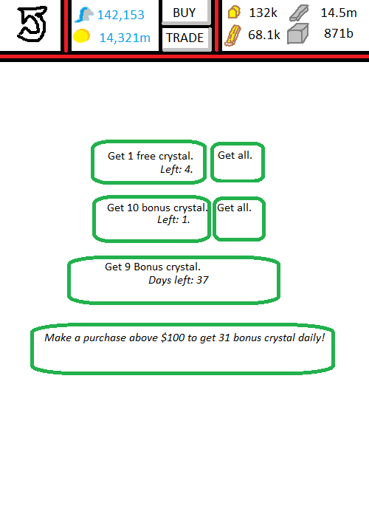

**User Interface (From main base).**Pressing the Crystal Mine Icon will open a mini-menu with the following options:  
 1. Go to Mine. Will open the Crystal Mine screen.  
 2. Receive all crystal. Will automatically receive all crystal from all 4 places, if applicable.  
Pressing anywhere else auto-closes the mini-menu.

**User Interface (Crystal Mine).**  
On the background graphic, there are 4 buttons.  
 1. Daily Crystal. Each base gives you 1 free crystal, every day. If you do not receive it one day, it cumulates, and can be collected at any date. On server reset daily you can collect 1 more crystal.  
 2. Daily crystal bonus. You receive 10 crystal for every 5 times you have collected crystal daily. This culminates as well, missing a day does not hold consequence. This counts with multiple bases as well. As you can collect 1 crystal per base, collect from 5 bases in one day and you can collect this bonus daily.  
 3. $20 benchmark. If you spend USD20 (or the foreign equivalent), you can collect 9 crystal for 20 days. This culminates. Miss a day, collect both days. The 20 day period also stacks up. If you charge 2 transactions of above $20, you’ll get 40 days.  
 4. $100 benchmark. For every $100 you spend, you’ll get 20 days of 31 crystal. This culminates.

**Graphics in Use.**GIMB_042. Crystal Mine. The icon for the crystal mine from the Main Base.  
GIMB_047. Glowing Crystal Mine. The main base icon notifying you that there is crystal ready to collect.

**Variables in use.***VS_CM_D01*. Daily variable. Every server reset, this variable is increased by a value of 1, for each base you have. If the value is higher than 0, a daily allotment of 1 crystal can be collected, reducing this variable by 1.  
*VS_CM_DB1*. Daily bonus variable. Every time the daily crystal is collected, this variable increases by 1. When this variable is above 5, you can collect 10 crystal, and reduce this variable by 5.  
*VS_CM_020P*. $20 purchase variable. Every time a transaction between $20-$100 is processed, this variable is increased by 20. If this variable is above 0, you can collect 9 crystal once daily, to reduce this variable by 1.  
*VT_CM020P*. Trigger variable for $20. Every time the $20 bonus crystal is collected, this variable increases by 1. If this variable is above 0, no more crystal can be collected. This variable is reset daily to 0.  
*VS_CM100P*. $100 purchase variable. Every time a transaction $100 or higher is processed, this variable increases by 20. If this variable is above 0, you can collect 31 crystal.  
*VT_CM100P*. Trigger variable for $100. Every time the $100 bonus is collected, this variable increases by 1. If this variable is above 0, no more crystal can be collected. This variable resets daily to 0.